Case 1-Eur-Bulgaria-Neolithic-Ceramic Female figure-VI Millennium BCE-77 mm

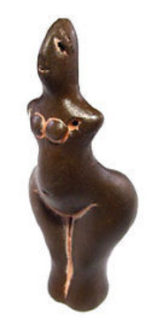 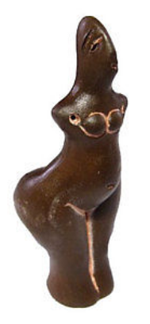 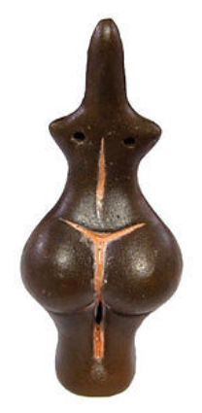 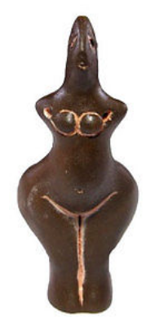

**NEOLITHIC CERAMIC IDOL –VI  MILLENNIA BCE**

**The Original was found in the ruins of a Neolithic settlement in the region of STARA ZAGORA , BULGARIA). And at the moment the Original is for a display in the Archaeological Museum in Stara Zagora.**

**Size: 77/33mm.                Weight: 17 g**